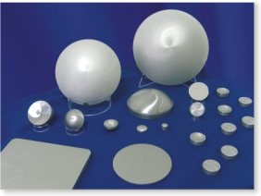NOTE: special requirements, tighter tolerances, other parameters, which are beyond the above specifications, are possible (upon request). PACKAGE: Thermal package (vacuum sealing or plastic bag), then put into cartoon boxes filled with shock resistant material.
Crystalline form
Monocrystalline; polycrystalline
N
Conductivity Type
[111] ± 2º; [100] ± 2º
Orientation
5÷40, others as agreed
Resistivity, Ohm*cm
≥ 99.999%
Purity
MATERIAL SPECIFICATION

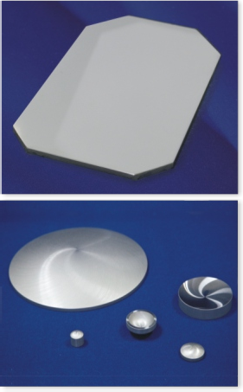Parameter Sizes Tolerances
0.1
0.15
diameters more than 200 мм
0.05
for diameters till 100 мм
forfor diameters 100÷200 мм
Parallelism, flatness for plano blanks
0.1
0.05
diameters more than 200 м
0.03
ffor diameters till 100 мм
for or diameters 100÷200 мм м
ETV, mm
<0.5 mm
Edge chips, mm
0.1÷0.8±0.1
Chamfer
0.1
0.15
200÷400
0.05
10÷100
100÷200
Thickness, sag, length and width, mm
400
320
monocrystalline
polycrystalline
Maximum diameter
sizes, mm:
0.2
0.1
200÷400
0.05
10÷100
100÷200
Diameter, mm
GENERATED GERMANIUM BLANKS/WEDGES/DISKS/WINDOWS

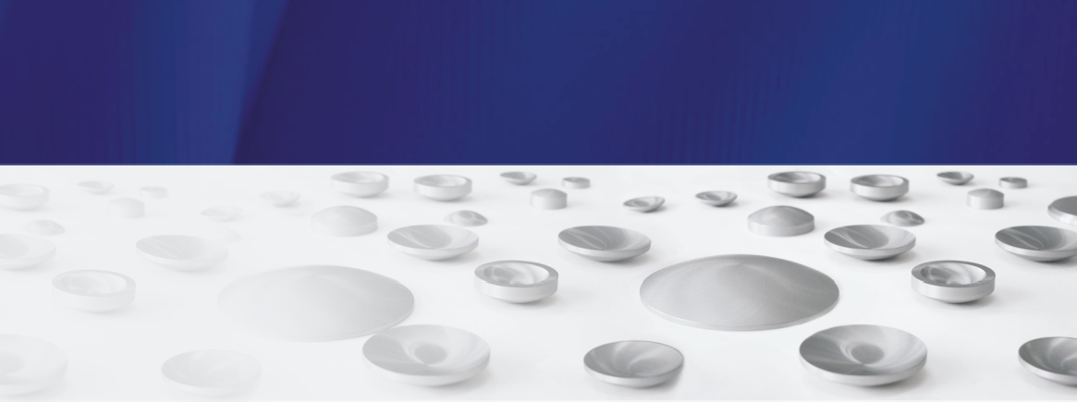Surface finish, Ra, μm generated blanks plano blanks

GERMANIUM FOR OPTICAL APPLICATIONS
Index of refraction
4.0032±0.0002 at λ= 10.6 μm at t=25ºC
2,5 3 4 5 6 7 8 9 10,6 11 12 13 14

46,1 46,3 46,5 46,5 46,5 46,3 46,0 46,9 46,4 46,2 38,0 48,5 39,0
Typical transmission on a polished sample (germanium monocrystalline, resistivity 5-40 Ohm*cm) 10mm thick depending on wavelength.
0.03 max at λ= 10.6 μm at t= 25ºC
Absorption coefficient, cm-1
≤ 4·10-4
Temperature coefficient of refraction index
≤ 2·10-4
Homogeneity of index of refraction
OPTICAL PROPERTIES

≤ 1.5;≤ 1.0; ≤ 0.5 (0.3 – instrument D7)
≤ 2.0;≤ 1.5;≤ 1.0

GERMANIUM FOR SOLAR APPLICATIONS
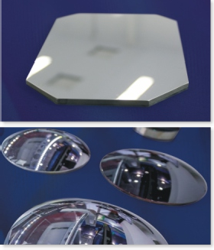
Parameter
Value
60/40
Scratch/Dig
<2
Parallelism (wedge tolerance), arc min
5/1
Power/Irregularity wave @ 633 mm
Protective/dimensional
Chamfer
from 0.4 to 25 mm
Thickness
from 8 to 300 mm
Diameter/Diagonal
Oval
Round
Rectangular
Shape
POLISHED GERMANIUM WINDOWS/WEDGES/LENSES/PRISMS
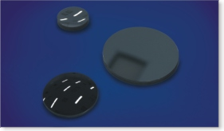
COATED GERMANIUM WINDOWS/WEDGES/LENSES
Antireflection protective DLC coatings to increase durability and transmission, enhance contrast and eliminate ghost images.
Maximum size – 140 mm for lenses, for windows, wedges and prisms. All request (specifications) are treated individually.

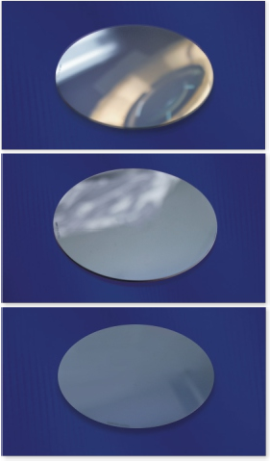
Parameter
Value
Generated
Nonworking surface finish
Polished, epi-ready
Working surface finish
According to SEMI М79-0211
Chamfer
No more than 20 µm
Warp
No more than 10 µm
Bow
No more than 10 µm
TTV
32.5±1.0 mm
Size of primary flat
145±10 µm
Thickness of wafer
100±0.5 mm
Diameter of wafer
0.01-0.06 Ohm*cm
ETV
P
Conductivity type
Not more than 300 cm²
Dislocation density
[100]+6°—>[111]
Crystallographic orientation
MONOCRYSTALLINE GERMANIUM SUBSTRATES FOR SOLAR CELLS

