www.rkt.ru

FULL RANGE OF ENGINEERING SERVICES

ABOUT US

ABOUT US

RKT-Engineering is a professional engineering providesrpecialisingin design, completion and installation of in-house MEP systems in residential, commercial, industrial and administrative buildings. Over 15 years, the company has successfully implemented the projects of various complexity and scale.
With a developed infrastructure, integrated automate business processes and a highly qualified expert team, RKT-Engineering has managed to occupy a leading position in the market of-in house MEP systems.

The Company provides a comprehensive range of engineering services, from the initial project concept to its implementation and subsequent project follo-wup activities

-design works;
-house MEP systems;

-commissioning works;

RKT-Engineering is an absolute leader in the development and implementation of energ-yefficient solutions, energy service agreements for residential, social and industrial facilities.

Highly qualified personnel

YEARS

Vast work experience

Single supplier
at all project stages

Direct distributor contracts with leading manufacturing plants

2

ABOUT US

RKT-Engineering is an exclusive business partner oRfusklimatTrading & Production Holding, a leading supplier of air conditioning equipment in the Russian market and provider of a comprehensive range of engineering services.

RKT-Engineering is a permanent active participant and partner of professional association: Moscow Chamber of Commerce and Industry, S-erelfgulatory organization Non-

(AVOK), and Association of Professionals in Industry of Climate (APIK). Efficient and close relationship between the partners of RK-ETngineering ensures a multifaceted approach to the implementation of engineering projects of any complexity.

We use only cutting-edge equipment of leading foreign and

implement technical solutions.
Thanks to a diversified approach the company is able to develop and implement the best possible and efficient

and business sector.

3

12 GOOD REASONSTO USE OURSERVICES

12 GOOD REASONS TO USE OUR SERVICES

BEST EQUIPMENT PRICES
We have entered into direct contracts with producers and buy large lots of equipment

CUSTOMIZED APPROACH
We hear and listen to our customers. We maintain a high quality of works regardless of the order budget

WE OWN A LARGE WAREHOUSEIN MOSCOW
This allows to hold stock on the most demanded equipment items.

PRICE AND QUALITY
We are always able to find an optimum technological solution, including with regard to a reasonable price to quality ratio.
UP TO 5 YEAR GUARANTEEFOR EQUIPMENT
We use only verified equipment and are certain of its quality.
IN-HOUSE DESIGNERS
help avoid mistakes during the selection of equipment

LOW COST OF USE
Close cooperation with the leading equipment producers significantly affects the possible cost of use.
Self-regulatory company, up to
RUB 3bln
CERTIFICATESAND LICENSES
They serve as a documented experience and qualification
IMMEDIATEFEEDBACK
We immediately address issues at all stages of work

EXTRA LONG LIFE CYCLE OF EQUIPMENT
Can guarantee long-term cost saving and affect strategic business development
4
TRAINED INSTALLATION TEAMS
High quality installation guarantees efficient and high quality operation of equipment
ANY FORM OF PAYMENT (CASH/BANK TRANSFER)
All convenient payment methods

ABOUT RUSKLIMAT HOLDING

ABOUT RUSKLIMAT HOLDING

RusklimatTrading & Production Holding is an absolute leader in the air conditioning market of Russia and CIS countries, an international company that accumulates experience of global leading producers from the climate industry, powerful potential of design offices and industrial design laboratories.
The holdingspecialisesin production of air conditioning and industrial equipment, provision of a comprehensive range of professional services in the field of design, installation, supply and maintenance of the equipment.

Currently,Rusklimatoffers more than 42,000 items: from compact home appliances to industrial ventilation, air conditioning, heating and air handling systems.

The current plan provides for the production of more than 15,000,000 equipment units per year, including 30% at the Russian plants.

In 2014,RusklimatTPH joined efforts with its partners to launch the largest in Europe industrial cluster of engineering air conditioning systems and electronics IKSEL inKirzhach(Vladimir oblast)
MORE THAN

OF PRODUCTS

More than 30% of products are made by Rusklimatat the Russian plants

Production facilities in Italy and South-Eastern Asia

The largest industrial cluster in Europe

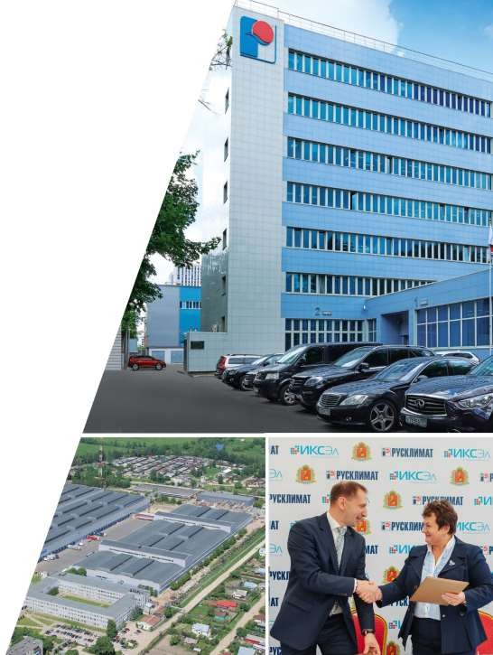
5

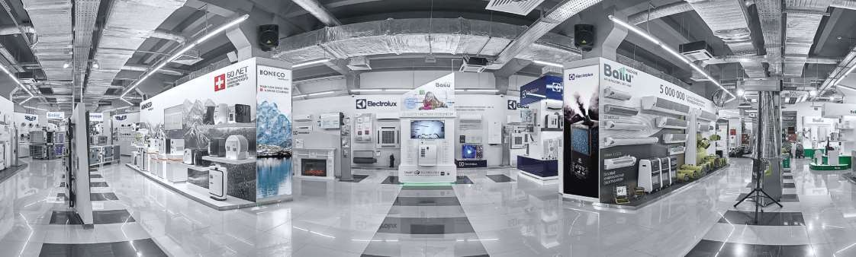
22 111 50 3500

14 000

branches in Russia
brands employees
customers all over the country

100 000
42 000 15 000 000

years of development
sq.m of warehouse premises
equipment items production units

ABOUT RUSKLIMAT HOLDING
6

DISTRIBUTION AND SERVICECENTRES

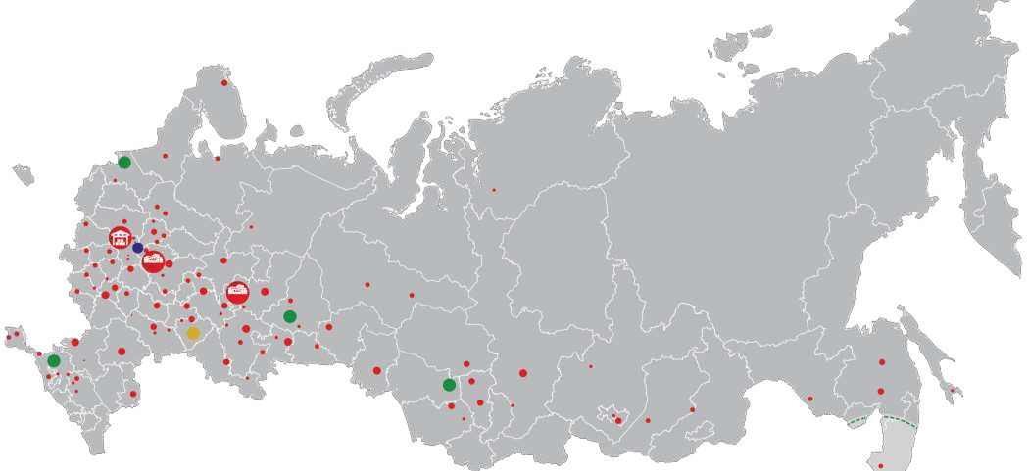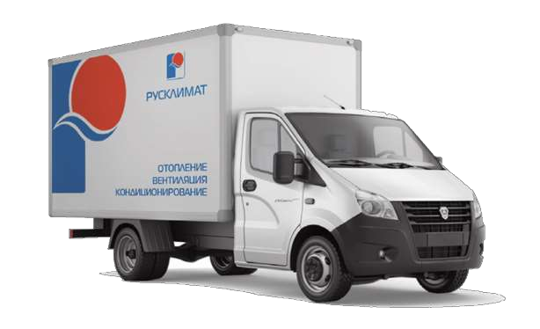Federal distributioncentre

Open regional distributioncentres
Open branches that deliver goods to customers inGAZellevehicles and semi-trailer trucks.
A regional distributioncentre is expected to open

Federal distributioncentre

Production facility

DISTRIBUTION AND SERVICE CENTRES
- centresare located in China (Guangzhou), Germany (Hamburg), Lithuania ( ), Latvia (Riga), FinlandK(otka) and Russia (Moscow, Krasnodar, NovosibirskK,irzhach, Yekaterinburg, Saint Petersburg, Vladivostok).
- In 2016,Rusklimatlaunched a quick and direct delivery service to customers: a customer places an order today and receives the goods tomorrow morning (for cities located within a 500 km radius of theRusklimatdistribution centre),
- The company has 111 regional representative offices.
- In 2018,Rusklimatwill launch a project to integrate representative offices in the supply chain to federal chain stores directly in the citwiehsere such stores are located.
- Widespread service network in the entire territory of Russia and CIS countries has more than 3a2u0thorisedservicecentres.
7

PRODUCTION FACILITIES

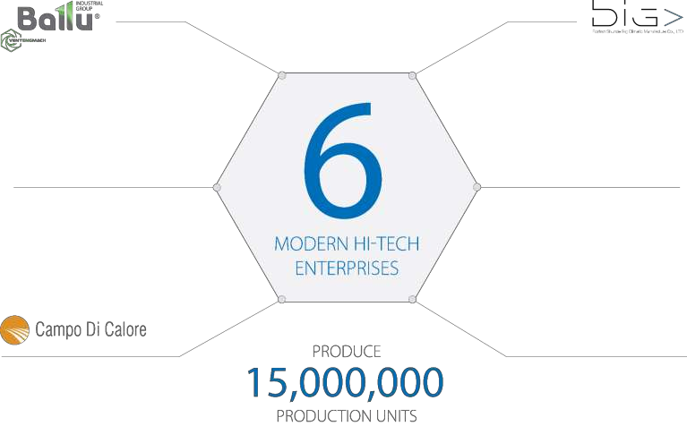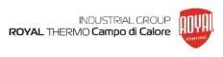Ventilation systems Control cabinets
Domestic air conditioning systems

Sectional, bimetal and aluminiumradiators
Electric water heaters

Italian designer radiators
(heat guns, air curtains, infrared heaters)
In 2014, TIH "Rusklimat" jointly with partners launched the largest in Europe industrial cluster INDUSTRIAL CLUSTER OF ENGINEERING, CLIMATIC SYSTEMS AND ELECTRONICS "ECSEL" in the city of
Kirzhach(Vladimir region)
MORETHAN
Of products of TIHRusklimatare produced on russianplants
Production in Italy and Southeast Asia
8

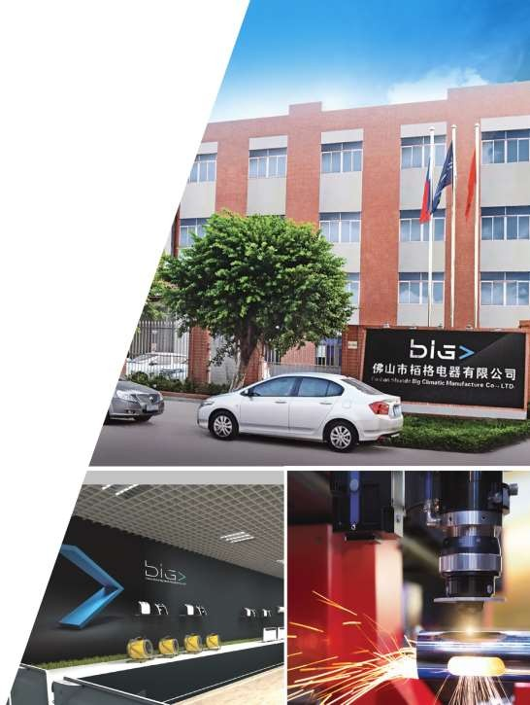

PRODUCTION FACILITIES

FoshanShundeBig Climatic Manufacture Co., LTD
The plant produces a wide range of heat equipment that shapes a new vision of comfortable living environment: electric convectors, electric heat guns, infrared heaters, floor, table and wall fan heaters.

The plant cooperates with leading design offices and industrial design laboratories. All the products comply with international and European quality standards.
The plant is a worldwide leader in production of electric convectors.

DESIGN CAPACITY
900,000
PRODUCTION UNITS per year

9

PRODUCTION FACILITIES

VentEngMachindustrial company
The industrial companyspecialisesin the production of industrial and sem-i industrial ventilation and air conditioning equipment: fram-epanel and single- unit installations, inline ventilators, network components, control cabinets, chillers, cooling towers, dry coolers, fire dumpers.

Equipment is used in various sectors of the national economy, including chemical, nuclear, food industries and is successfully exported to more than 30 countries worldwide.

PRODUCTION CAPACITY
500,000
PRODUCTION UNITS per year

INTERNATIONAL QUALITY STANDARDS

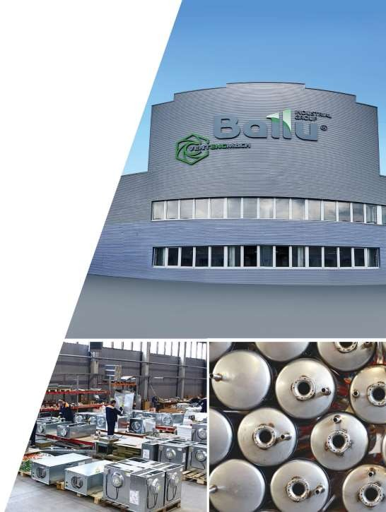

10

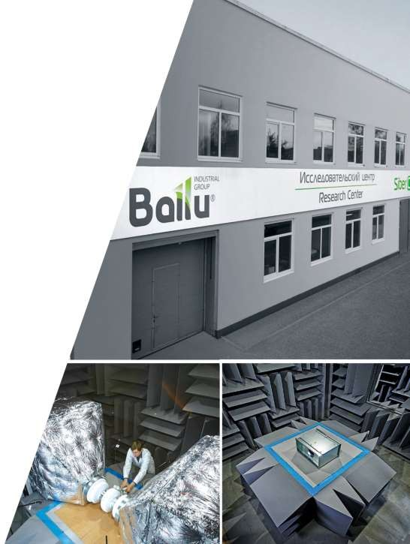

PRODUCTION FACILITIES

RESEARCH CENTR

Modern researchcentre SiberCool Lab
TheBalluSiberCoolResearch Lab Scientific Research Centre became a basic site for development and testing of theSiberCool technology suite to ensure
reliable and efficient operation of the equipment under very strong temperature gradients. Thecentreincludes a low-temperature, acoustic, aerodynamic and hydraulic laboratories, control process monitoring stand.

A joint project with international
producers of components and parts

11

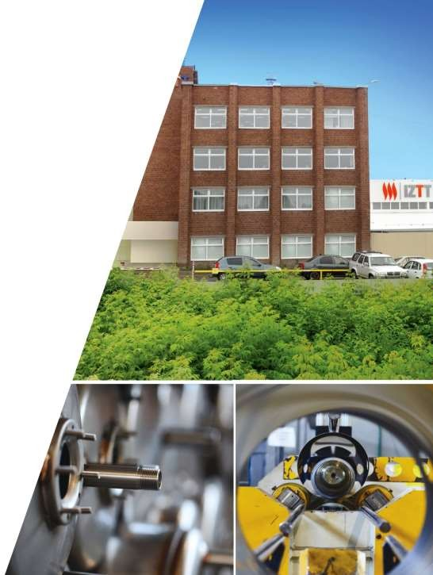

PRODUCTION FACILITIES

Izhevsk Heating Equipment Factory, Izhevsk
The largest Russian producer of household and industrial equipment: heat curtains, electric and gas heat guns, infrared heaters, h-oaitr heating systems and other products.

All the products comply with the requirements of the EU technical regulations and are supplied not only to Russian consumers but also to countries of the Customs Union, Baltic States, Scandinavia, Western Europe.
The enterprise is certified according to the quality management system standards ISO9001-2011.

DESIGN CAPACITY
1,500,000
PRODUCTION UNITS per year
INTERNATIONAL QUALITY STANDARDS

12

PRODUCTION FACILITIES

Izhevsk Heating Equipment FactoryK,irzhach
The second production site of the Izhevsk Heating Equipment Factory is the largest plant producing storage water heaters, electric convectors and other products with a production capacity of more than 1,000,000 units per year.

In 2015, the production facility of the IZTT branch waasuthorisedby the world leading brands to launch production of a wide range of electric water heaters and convectors Electrolux, ZanussBi,alluunder their license and technical supervision.

PRODUCTION CAPACITY
700,000
PRODUCTION UNITS per year

INTERNATIONAL QUALITY STANDARDS

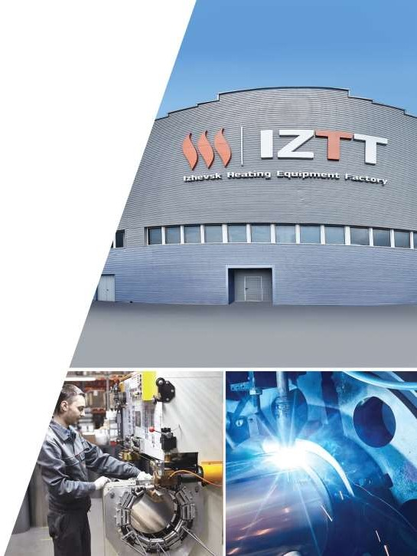

13

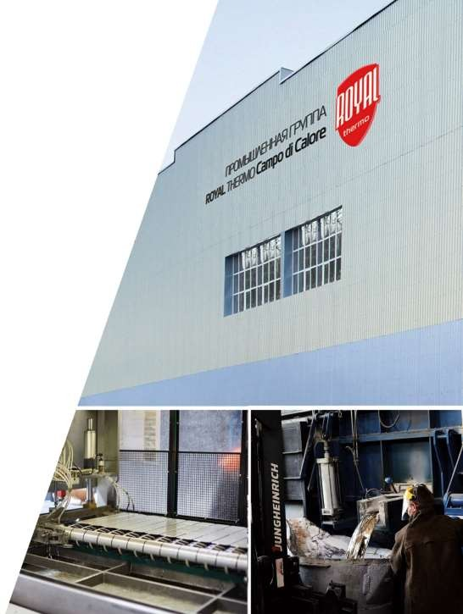

PRODUCTION FACILITIES

Royal Thermo Campo Di Calore Production Group
A revolutionary Russian project byRusklimatHolding in Vladimir oblast to produce
aluminiumand bimetal heating radiators by a pressure casting method. The factoryspecialisesin production of hi-tech heating devices and units for energy efficient construction, offers an innovative product line and has an estimated capacity of 14,000,000 sections per year.

By 2017, the production facility waslocalisedby 99%.

DESIGN CAPACITY
14,000,000
SECTIONS PERYEAR
INTERNATIONAL QUALITY STANDARDS

14

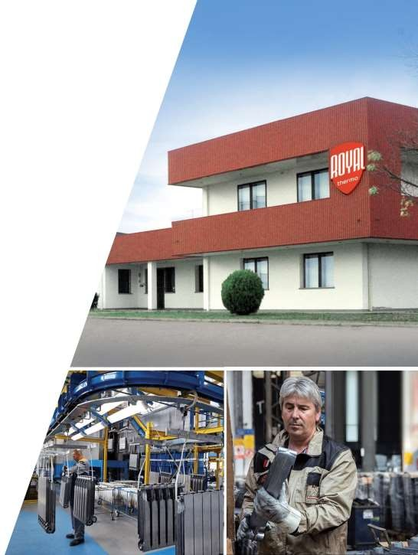

PRODUCTION FACILITIES

Campo DiCalorePlant
Campo DiCaloreis a plant that produces bimetal designer radiators RoyTahl ermo
in Orgiano(Italy). This ancient city is located in a picturesque valley at the foot of the BericianHills.
Campo DiCalorefollow traditions of Italian artisans by uniting its ideas in radiator

even more comfortable.

Fully automated production is certified in accordance with
the ISO 9001, ISO 14001 international standards.

INTERNATIONAL QUALITY STANDARDS

15

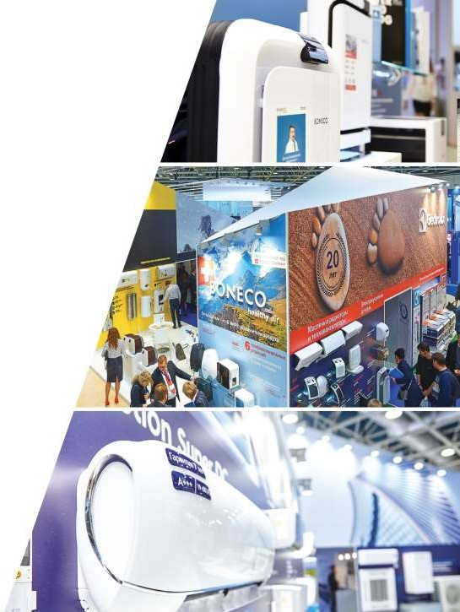

WORLD LEADING BRANDS

WORLD LEADING BRANDS

RKT-Engineering, being a business partner oRfusklimatTPH, has entered into direct contracts with the leading producers of engineering and air conditioning equipment
from Germany, France, Spain, Italy, Israel, Latvia, Denmark, Sweden, UK, Russia and other countries.

It cooperates with more than 50 world famous brands
based on provisions of an exclusive contract.

16

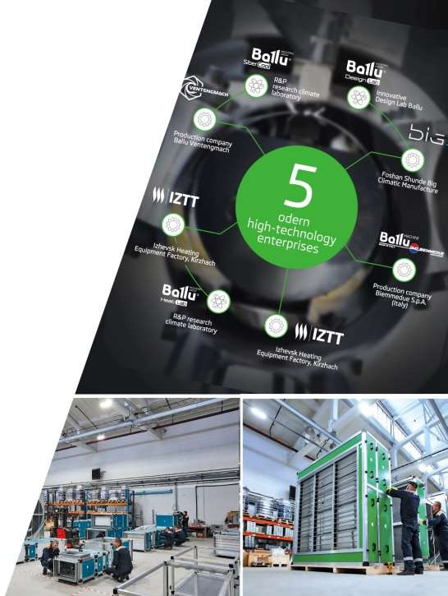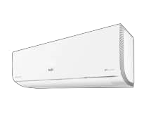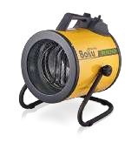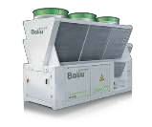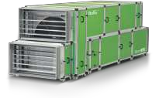 WORLD LEADING BRANDS

The industrial concern owns and manages the largest international production lines, plants and laboratories both in Russia and abroad. This infrastructure includes four full cycle plants VentInzhMash(Russia), IZZT, Izhevsk Heating Equipment Factory (Russia), BIG (China)-,sjotoinctk production companyBallu-Biemmedue(Italy) and two largest engineering air conditioning laboratoriesBalluSiberCoolResearch Lab andBalluInnovative Design Lab.

Ballu
equipment per year. Bally is a leading supplier of engineering air conditioning and ventilation system supplier to the international market, including fram-epanel ventilation units, chillers, VRF systems.

The industrial concern is a leading seller of household and professional climate control equipment in the markets of Russia, CIS and Eastern European countries. Annually, more than 350,000 heat guns, 3,000Ballu-Biemmedueheat generators,
100,000 heat curtains, 300,000 air conditioners, 500,000 convectors and more than 200,000 heat ventilators are supplied to the world market.

17

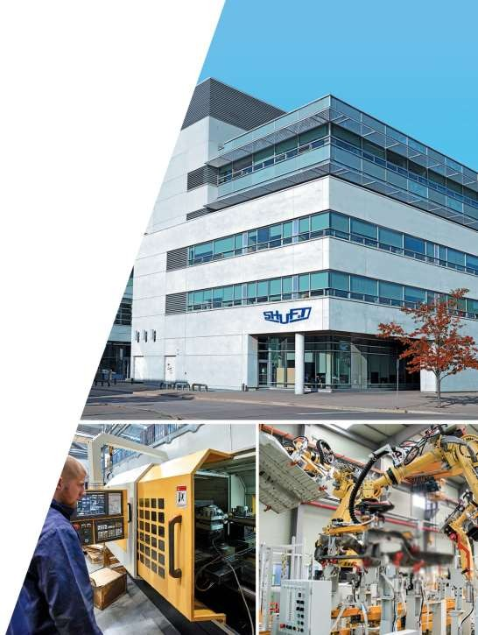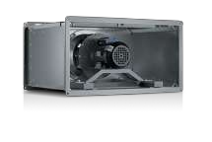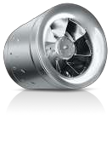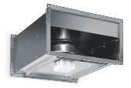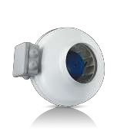 WORLD LEADING BRANDS

A European machine building holding thast pecialisesin development and production of equipment for ventilation systems established in 1998 in Copenhagen (Denmark).
Shuft has been operating on the Russian market since 2001. During the development of the company, more than 10,000,000Shuft products found their buyers in Russia.

Shuft technologies and equipment are implemented and used at many facilities all over Russia. Those include unique projects and facilities with a high level of technical requirements, including TANEKO oil processing complex, TheVostochnyCosmodrome, SkolkovoInnovation Centre.

areas as:

-efficient air distribution;

18

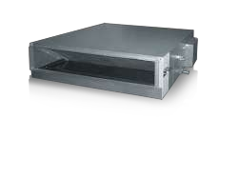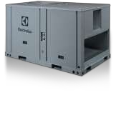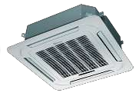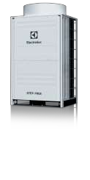 WORLD LEADING BRANDS

Electrolux (Sweden) is one of the world leaders in production of household and professional equipment that sells more than 40 million products per year for buyers in 150 countries worldwide.

creation of optimum micro-climate: humidifiers and air washers, ho-wt ater generators, air
conditioners, fan heaters, under floor heating, electrical fires and heaters.

Electrolux is one of the leaders in household and commercial air conditioner segments. Every tenth split air conditioning system installed in Russia is Electrolux VRF system. According to Litvinchuk Marketing agency, Electrolux VR-sFystems have been rated over 5 years among
TOP-5 market leaders, and based on the results of 2017, they were rated second best in terms of sales of ful-lsize units in the Russian market.

19

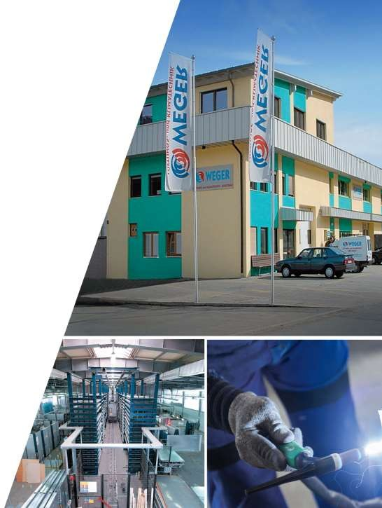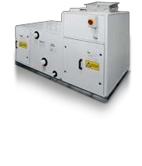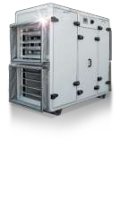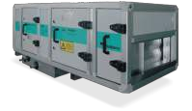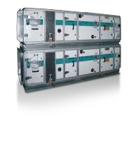 WORLD LEADING BRANDS

Wegeris a European producer of high quality ventilation equipment, intake and exhaust and
recuperation systemsW. egerhas evolved from a producer of accessories for ventilation equipment
for intake and exhaust systems to one of the most sta-toef-the-art plants for ventilation system
-edge laser metal processing systems.

The Company has gathered more than 40 years of experience in production of intake and exhaust installations and has always been focused on innovations and development of more and more perfect solutions in the area of ventilation and air conditioning.
Radfeld(North Tyrol, Austria)L, ienz(Eastern Tyrol, Austria) and Kiens(South Tyrol, Italy). Only high quality parts made by the leading European producers are used to produce installations.

Wegeris a member of RLT, an association that unites leading European, first and foremost, German producers of equipment for central air conditioning systems. Compliance with RLT standards is a guarantee of reliability and best technical equipment specifications.

20

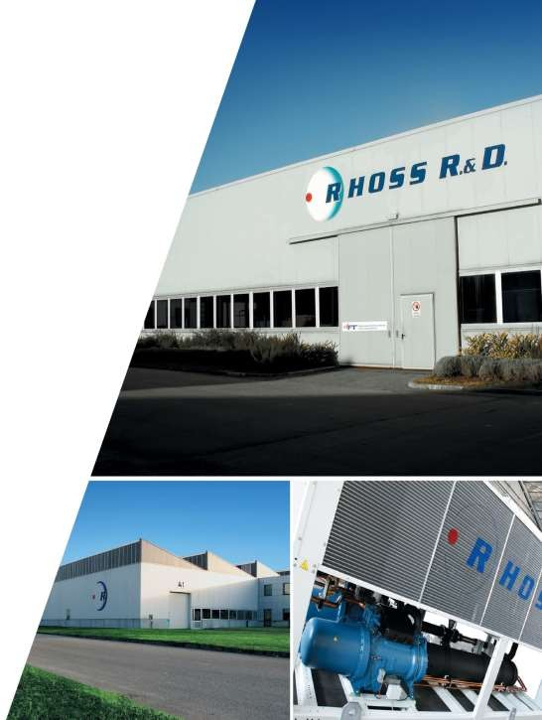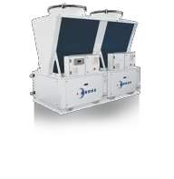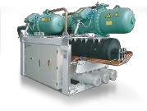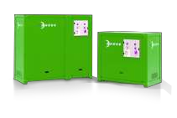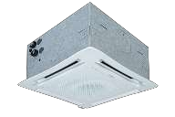 WORLD LEADING BRANDS

RhossS.p.a. is a member of IRSAP Industrial Group, being one of the oldest equipment producers for commercial air conditioning in Europe.
Established in 1968R, hosshas guaranteed cutting-edge technologies, quality and highest level of service for more than 40 years now.

TheRhossR&D Lab researchcentreis one of the largest and most advanced in Europe, being
simultaneously an official EUROVENT test facilitRy.hossR&D Lab means more than 3,000sq.m
of testing stations, including low temperature, acoustic, aerodynamic and hydraulic laboratories; more than 50 scientific workers and engineers; scientific and research cooperation with the leading European technical universities.

In 2017,RhossS.p.acelebrated its 20th anniversary in the Russian climate market by having approached this date with an impressive result: more than 1,700 installed chillers on more than 800 facilities in Russia. According to the results of 2016, the concern has confidently occupied the first place in terms of chiller sales, based on the total cooling capacity.

21

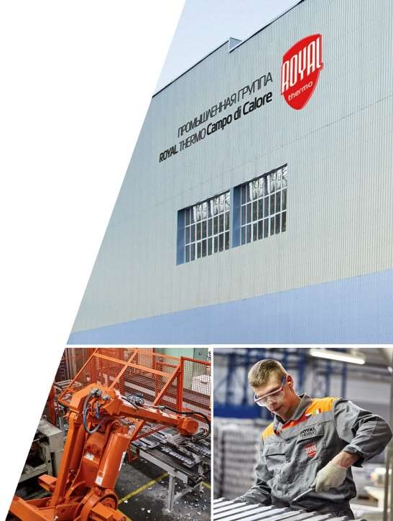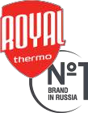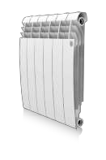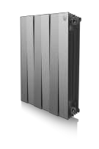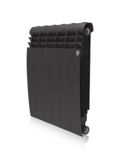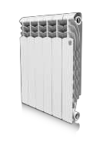 WORLD LEADING BRANDS

The RoyalThermoCampo DiCaloreindustrial group is a Russia-nItalian producer of modern
heating systems with its headquarters, design office and design studio in Vincenza province, plants in Russia- RoyalThermoRus and in Italy Campo DiCalore.

RoyalThermo -place
casting complex with a record performance: one section per 11 seconds. Through cooperation
with the Polytechnic University of Milan and Sanitary Engineering Scientific and Research Institute,

boasting the best heat engineering, robustness and hydraulic specifications.

Each RoyalThermoradiator is protected from fraud, has a warranty period of 25 years, is insured to the amount of USD 1,000,000 to ensure consumer protection and peaceful use.

22

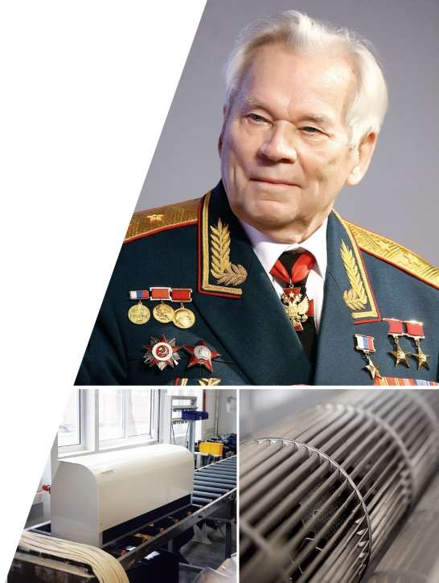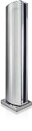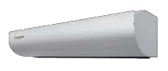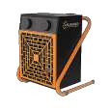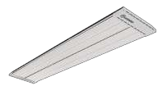 WORLD LEADING BRANDS

Kalashnikov thermal equipment is produced by using the most reliable materials and units that withstand the maximum number of switching on/off operations. The equipment operation is tested under high load conditions.

operating conditions.

The Kalashnikov brand creates reliable operation standards for consumers and maintains

in air curtains, fan and infrared heating.

23

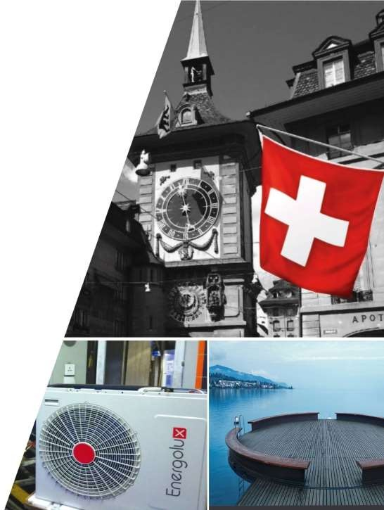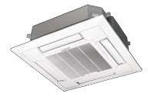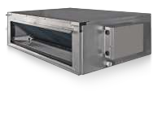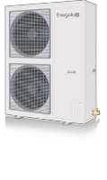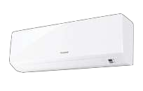 WORLD LEADING BRANDS

Energoluxis a monopolist in the area of production, maintenance and supplies of industrial lighting equipment in Luxemburg. Since 2008E,nergoluxhas beenspecialisingin production of generators and modules of min-icogeneration plants, energy distribution and protection systems in large buildings.

In 2010, the company enters a new market in Switzerland and makes a decision to create
unique products to provide each house with heat and comfort.

Currently, products made undeEr nergoluxlabel, including industrial and household air conditioning and heating systems, humidifiers, air dryers and cleaners are on active demand in European and Asian markets and win the hearts of the most sophisticated consumers

European R&Dcentreswhere more than 40 highly qualified specialists work on the unique climate control products.

24

PARTNERPROGRAMS

PARTNER PROGRAMS

For many years, RK-TEngineering has maintained and treasuring an impeccable business reputation and expert status.

We develop and implement unique integrated solutions for our
strategic partners to solve specific business tasks.

25

PARTNERPROGRAMS

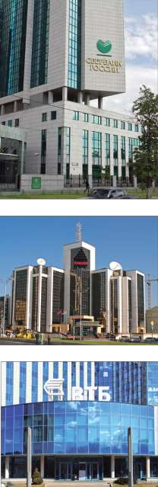Program for Sberbank of Russia OJSC

Objective:
To develop a systemic approach when outfitting facilities in territorial banks of Sberbank of Russia OJSC (19,000 branches) in order to cut purchase prices and possess engineering air conditioning systems through the unification of MEP systems.
Tasks of RKT Engineering:
To develop unified technical solutions, prepare a feasibility study concerning decrease in expenses for further
equipment, design, assembly, maintenance, technical personnel training.
Outcome:
8,200,000,000 or 32.2% of planned funds for the use of-hinouse MEP systems.

Program for Lukoil PJSC
Objective:
To develop typical engineering solutions for filling stations. Quick logistics.
Tasks of RKT-Engineering:
To act as a single supplier and prepare the project, design, assembly, installation, maintenance, training.
Outcome:
More than RUB 3,000,000 of the initial price of engineering equipment in savings when outfitting every filling station of Lukoil PJSC.

Program for VTB Group
Objective:
To develop
Tasks of RKT-Engineering:
To create a unified program for supplies and use of HVAC equipment all across Russia. To prepare a feasibility study for decrease in expenses for the use of -in
Outcome:
expenses for the use of in-
26

PARTNERPROGRAMS

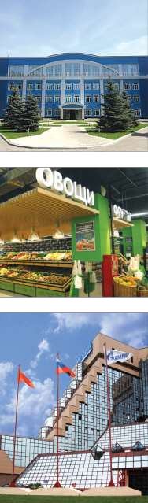Turnkey Heat Program forMosoblgazGUP MO

Objective:
To create a chain of multifunctional service and engineerincgentresbased onMosoblgazGUP MOinterdistrict complexes of gas enterprises.
Tasks of RKT-Engineering:
To develop and implement the Turnkey Heat Program. To establish an efficient and modern dealer network to resolve tasks relating to the growth in profitability of business along with enhancing the scope of social priorities relating to the servicing of various groups of consumers, inhabitants of Moscow suburbs.
Outcome:
threefold increase in gross earnings from other activities.

Program for X5-RETAIL GROUP
Objective:
To develop typical engineering solutions, complying with a unified design principle. Adaptation of resolutions to any type of point of sale.
Tasks of RKT-Engineering:
To act as a single contractor and supplier, carry out p-rdeesign, design, assembly, installation, maintenance works
and technical personnel training.
Outcome:
design period decreased by 1.5 times. Expenses for energy resources cut more than by 28% due to the use of energy efficient air conditioning equipment.

Warm House Program for GazpromMezhregiongazLLC
Objective:
To create an efficient managing company for sale of climate control and boiler equipment through the network of gas distributionorganisations. Transformation of points of sales in efficient engineerincgentres, development of design, assembly, and in-house MEP system installation services.
Tasks of RKT-Engineering:
To develop and implement the Warm House Program. To develop a project, feasibility study, equipment supplies, training for gas distribution companies, maintenance.
Outcome:
fourfold increase in gross earnings from other activities of GazproMmezhregiongazLLC.
.
27

PARTNERPROGRAMS

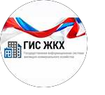
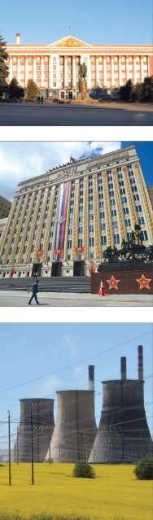Program for the housing and utilities infrastructure committee in Kursk Oblast

Objective:
To develop a program for improvement of heat supply to residential houses and to cut expenses for system maintenance.
Tasks for RKT-Engineering:
To develop a project, feasibility study, select equipment, design, assembly, training.
Outcome:
To decrease the price of apartment heating for 1sq.m by 3-4 times compared to heating from acentralisedheating source.

Modernisationof heat supply systems in military camps of the Ministry oDfefenceof
the Russian Federation based on gasification anddecentralisationof heating systems
Objective:
To develop a program fordecentralisedgasification of military campsm, odernisationof boiler houses and household
heating equipment in order to significantly improve energy efficiency and cut costs.
Tasks for RKT-Engineering:
To develop and approve a technical solution portfolios. To prepare a project, design, assembly, maintenance, training.
Outcome:
To cut capital investments in heat sources by 30%, heat networks by 3 times, cut annual fuel consumption by 50%, decrease in the price of supplied heat by 2.5 times.

Project fordecentralisationof heat supply in rural areas for constituent entities of the Russian Federation
Objective:
To cut consumption of all types of resources (financial, energlya,bour) to supply consumers with heat energy in rural areas, improve social tension and increase the quality of heat supply.
Tasks for RKT-Engineering:
To develop a project, feasibility study, select equipment, design, assembly, training.
Outcome:
- no more annual growth in payments for arrangement of heat supply to consumers for the period of 3 to 5
for heat supply;
- resource and energy saving, improved energy efficiency;
- increase in the quality of life of citizens and comfort of housing.
28

REFERENCEPROJECTS

REFERENCE PROJECTS

Kindergarten inBeskudnikovo
Moscow
Tasks:
sewerage sections as a single contractor.
Implemented solution:
the design solution has been improved in the course of construction and assembly works, technical inspection was made in the course of facility construction, besides works were carried out to ensure installation of technically demanding heating and ventilation equipme.nt

Residential complexNovogorsk
Khimki, Moscow oblast
Tasks:
Implemented solution:
were performed.
29

REFERENCEPROJECTS

REFERENCE PROJECTS

IzumrudnayaDolina Residential Complex
Moscow oblast
Tasks:

-house MEP systems;
Implemented solution:
-made heating equipment has been installed;

Municipal market
City of Ryazan
Tasks:
To create a comfortable micro-
specific features. Implemented solution:
Supplies and assembly of air conditioning, ventilation, cold supply, automation, electricity supply, electric lighting systems.
Total area of the facility: 17,000sq.m

Greenwood Business Park
Moscow oblast,Krasnogorskdistrict, post officePutilkovo, 69km of the Moscow Ring Road
Tasks:
To develop, assemble and deliver i-nhouse MEP equipment for energy efficient air conditioning, ventilation,
heating systems, etc..
Implemented solution:
Supplies and assembly of air conditioning, ventilation, cold supply, automation, smoke ventilation systems. Total area: 240,000sq.m
30

REFERENCEPROJECTS

REFERENCE PROJECTS

Toyota Office and Industrial Complex
Moscow oblast,Mytishchidistrict, 84km of the Moscow Ring Road
Tasks:
To design and assemble industrial heating, ventilation, air conditioning systems. Implemented solution:
Design, supplies, installation: Shuft, Weger ventilation equipment; Rhossrefrigeration units;
Dia Norm steel panel radiators;
Termokey

Regional perinatalcentre Kursk
Tasks:
To create a unique technical solution for air cleaning in medical premises (surgery rooms, clean rooms) with an
automated BMS accounting system.
Implemented solution:
The best possible technical solution with air cleaning and disinfection system has been selected, modern explosion-proof energy efficient equipment in pharmaceutical design has been installed, thcentre has been equipped with an automated BMS recording system.

Regional perinatalcentre Kursk
Tasks:
To create a unique technical solution for air cleaning in medical premises (surgery rooms, clean rooms) with an automated BMS recording system.
Implemented solution:
The best possible technical solution with air cleaning and disinfection system has been selected, modern explosion-proof energy efficient equipment in pharmaceutical design has been installed, thcentre has been equipped with an automated BMS recording system.
31

www.rkt.ru

Thank you for your attention!

