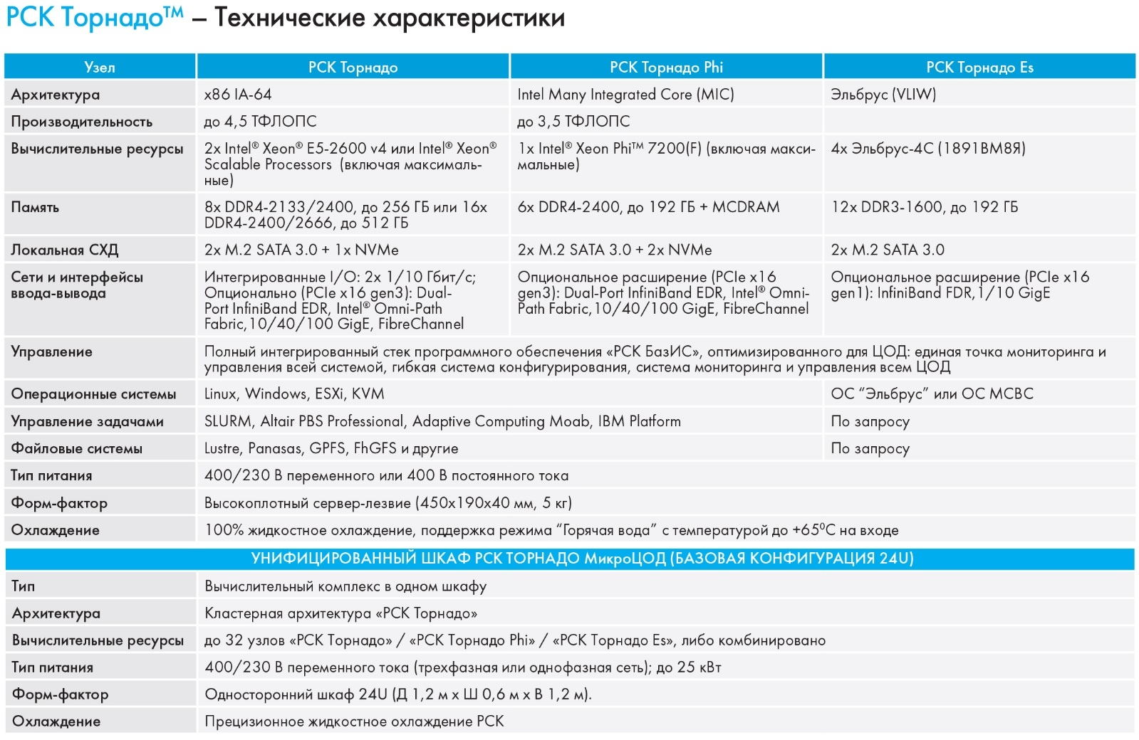

Пакеты расширения RSC Tornado Expansion Pack
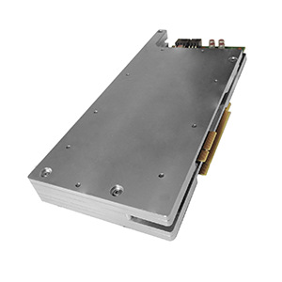
- Пакет расширения RSC Tornado HPC Expansion Pack, ориентированный на высокопроизводительные вычисления с использованием двух сопроцессоров Intel® Xeon Phi™ 7120X, позволяет повысить производительность вычислительного узла до 3,74 ТФЛОПС;
- Пакет расширения RSC Tornado VDI Expansion Pack предназначен для задач виртуализации и удаленного доступа к рабочим местам, а также областей CAD/CAM/CAE. Построен на основе карт AMD FirePro™ S10000 или NVIDIA GRID™ K1/K2 и высокопроизводительного твердотельного накопителя Intel® SSD DC P3700;
- Программно-аппаратный пакет расширения RSC SDM Expansion Pack позволяет реализовать концепцию RSC Software Defined Management, улучшая управляемость и увеличивая доступность вычислительных систем для пользовательских приложений;
Возможно создание и других специализированных пакетов расширения согласно конкретным запросам заказчиков.

TECHNICAL SPECIFICATION
Architecture | RSC Tornado Cluster Architecture
Features | A complete solution in one cabinet  - Direct liquid cooling system (“Warm water” mode support);  - Communication system;  - Data Storage;  - Single Point of Monitoring and Management
Unique features | - Low-noise;  - Energy effectiveness;  - Absence of moving parts, such as fans and traditional hard disk drives (solid state drives are used instead);  - Compact;  - Flexible installation options: limited by space and mass requirements only – doesn’t require additional forced air cooling
Scalability | Not supported

COMPUTE CABINET (BASIC CONFIGURATION)
Compute Field Type | Homogeneous (Heterogenous with RSC HPC Expansion Pack)
Performance (RMax) | 60 TFLOPS
Compute resources | Up to 32 basic x86 architecture compute nodes (306 processors, 6732 cores, 13464 threads Intel® Xeon® E5-2699 v4)
Memory | 8 TB
System management | Fully integrated software stack for High Performance Computing “RSC BasIS”:  - Single System Management Point,  - Flexible Software Configuration System,  - Supercomputer and Data Center view and management system
Operating Systems | Linux (RedHat, SUSE, Debian, CentOS, Scientific Linux), MS Windows
Job management | SLURM, Altair PSB Professional, Adaptive Computing Moab, IBM Platform LSF
Parallel File Systems | Lustre, Panasas, GPFS, FhGFS and others
Libraries, Compilers and Tools | Intel® Cluster Studio, PGI compilers, standard MPI libraries
Power consumption | Up to 35 kW
Cooling | “RSC Tornado” direct liquid cooling system: up to 50kW per Cabinet;  Option: integration with existing customer’s cooling system
Formfactor | 24U
Dimensions | H 1.2m (40 in.) х W 0.8m (32 in.) х D 0.8m (32 in.)
Weight | Up to 430kg (1,874 lbs.)
Power | Up to 125A at 400/230V (three-phase, neutral and ground)

COMPUTE NODE (BASIC CONFIGURATION)
Processor | 16-core Intel® Xeon® E5-2697A v4 (2.6GHz, 32 threads, TDP 145W) or other Intel® Xeon® E5-2600 v4 family processors;  2 processors per node;  Intel® Turbo Boost Technology is permanently enabled (+300MHz with all cores utilized)
System board | Intel® Server Board
Memory | DDR4-2133/2400, up to 256GB per node
Local storage | Solid State Drives; up to 2 SSDs per node
Communication  I/O interfaces | Integrated I/O: FDR InfiniBand, 56Gbps; QDR InfiniBand, 40Gbps; 10 GigE;  Optional enhancement (PCIe x16 gen3): Dual-Port InfiniBand EDR, Intel Omni-Path Fabric, Quad-Port 10/40 GigE, FibreChannel
Service I/O interfaces | 2x GigabitEthernet, IPMIv2 support
Cooling | Water cooled, coldplate, “Hot Water” mode support (up to 65⁰C inlet water)
Power | Independent per node, 180-240V 50Hz
Formfactor | High Density Blade
Expansion | Supported, with RSC Expansion Pack
Hot Swap | Supported, with no influence to any other nodes

RSC Tornado Expansion Packs

