FABION 2
NEW FLAGSHIP HARDWARE AND SOFTWARE SYSTEM
FOR LIFE SCIENCE COMPANIES,
RESEARCHERS AND INNOVATORS WORKING WITH BIOPRINTING

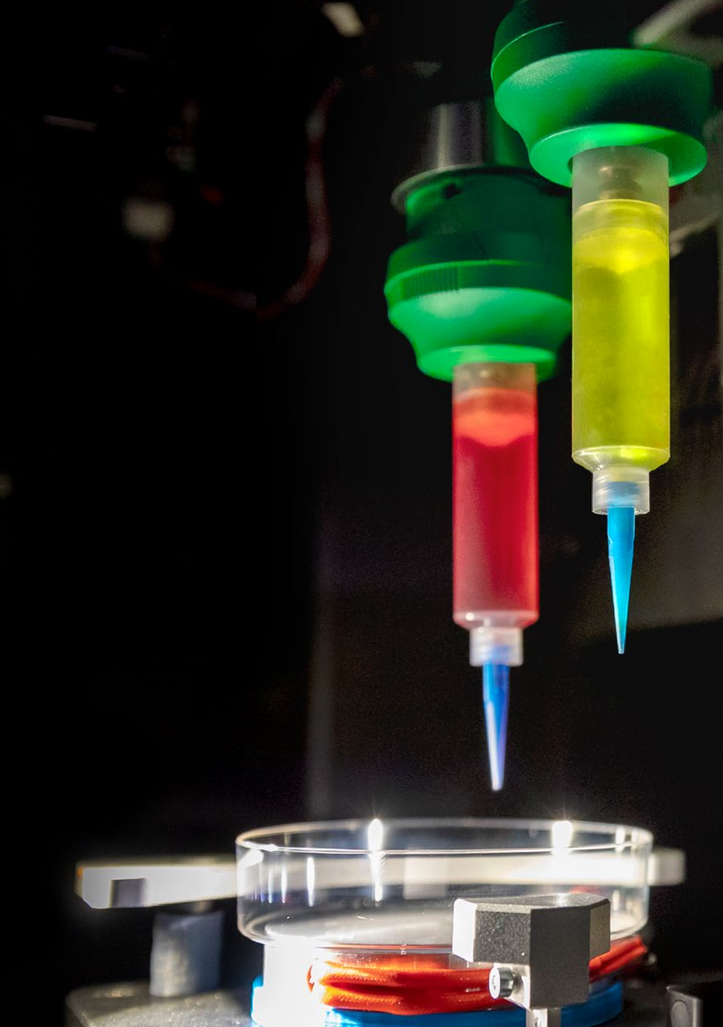

HOW DOES IT WORK?
FABION 2 is the world’s most multifunctional bioprinter
in terms of its ability to use a wide range of materials, including various types
of bioink and hydrogels.

This modular 3D bioprinter
is equipped with different types of nozzles which can handle
up to five different materials in one print.

WHAT IS IT?
FABION 2 is a tool that can execute a number
of biotechnological protocols, using extrusion to print functional organ constructs (organoids).

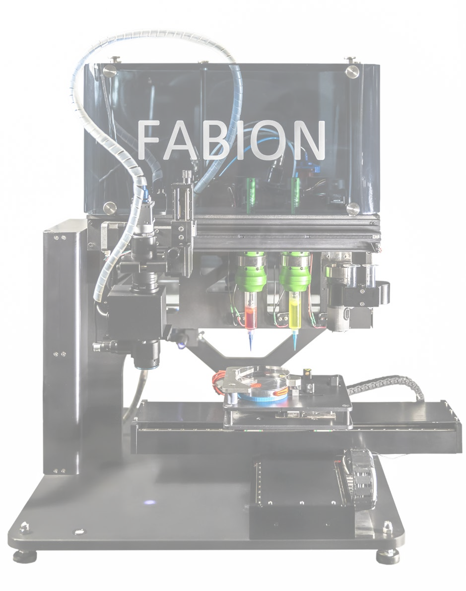

ADVANTAGES

FABION 2 is the next generation bioprinter able to print complex structures using tissue spheroids and a wide range of hydrogels with different types of polymerization:
thermosensitive hydrogels, multi-component hydrogels, photosensitive, Ph-sensitive
and ionic-sensitive hydrogels.

The key technological feature is high-speed printing with single tissue spheroids managed by a special device, developed by 3D Bioprinting Solutions.

This proprietary device’s core element is a print head which operates as a “turnstile” controlling the injection
and printing of single tissue spheroids. The competitive edge of this printing method is high cell density as well as the synthesis of extracellular matrix proteins within spheroids creating highly viable functional tissue constructs.

Printing dispensers are calibrated using a unique
laser positioning system with unrivalled positioning accuracy of 5 µm, enabling FABION 2 to print highly complex structures.

SOFTWARE PRINTING TOOLS

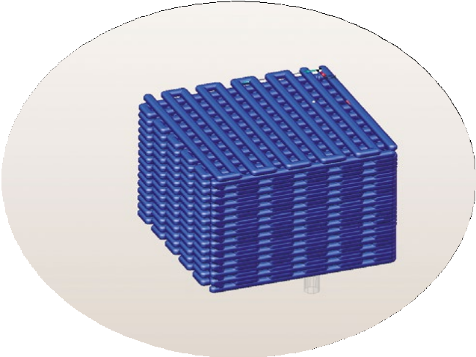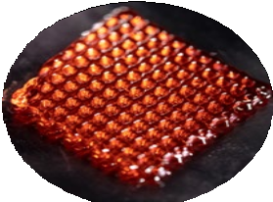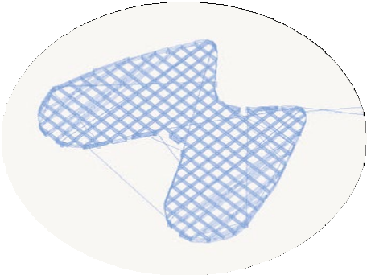The print management system (HMI-interface) controls the bioprinter to ensure the stable bioprinting of tissue spheroids and various hydrogels, with the development of G-code embedded control programs.
The SprutCAM software system develops control programs to create organ constructs of varying complexity layer-by-layer from a digital 3D model. The system enables the creation of control programs for extrusion printing with spheroids.

Two Fishman Smart Dispensers
- Printing with collagen, alginate, pluronic F-127 etc.;
- Minimum dispensed volume: 0.00023 mL
(tubus volume 3 mL). – Maximum tubus volume: 30 mL;
- Maximum dispensing rate: 0.771 mL/s (for tubus volume 30 mL);
- Liquid viscosity: 0.001 to 800 Pa∙s.

Preeflow dual dispenser with real-time mixer
- ViscoTec eco-DUO330;
- Repeat accuracy > 99%;
- Dosing accuracy ± 1%;
- Min. dosing quantity: 0.005 mL;
- Installation of Preeflow 2k dispenser (line eco DUO) together with the mixer improves the mixing of gel components and provides for a more qualitative polymerization.

Printing Head
- Print speed: 1 tissue spheroid per 3 seconds;
- Tissue spheroid diameter depends on chip used (250, 300, 350 mm);
- Tissue spheroid suspension is required for printing.

One Nordson 784S-SS spray valve
- Spray function is used for two-component polymerization;
- Actuating air pressure required: 70 to 90 psi (4.8-6.2 bar);
- Maximum fluid pressure: 25 psi (1.7 bar);
- Fluid inlet thread: 5/16-24 UNF tapped hole;
- Cycle rate: over 400 per minute;
- Maximum operating temperature: Autoclaving 260°C (500°F).

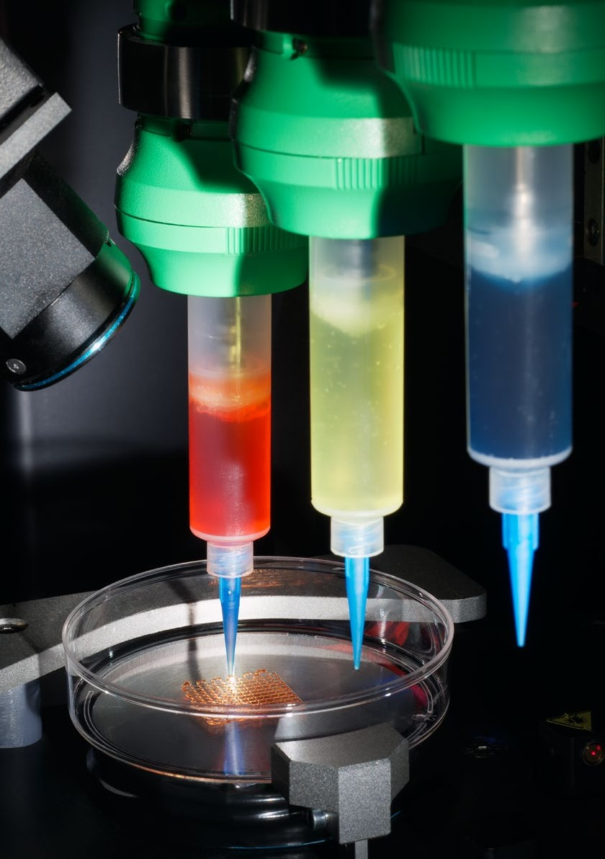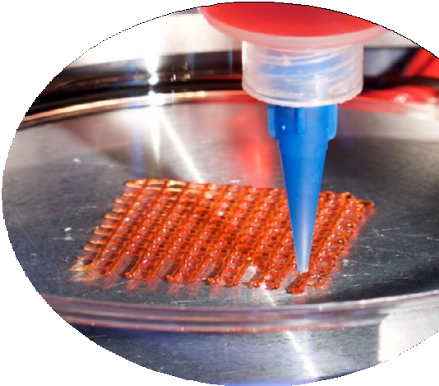

PRINTING MATERIALS

Collagen
Printing with cell-laden collagen (up to 5 wt.%) means that analogues of biomimetic tissue constructs can be modelled in 3D using cells from various origins.

Fibrinogen-thrombin
Biocompatible with many cell types. Has demonstrated
its effectiveness in angiogenesis modelling and the creation of substrate for follicular structure development
and maturation.

Alginate
The standard hydrogel for the bioprinting and modelling
of musculoskeletal organ structures such as bone, cartilage
and ligament. Objects in complex shapes (tubular structures, grids, etc.) can be printed using Alginate.

Gelatin Methacrylate
Produces 3D constructs with high complexity and predictable bio- mechanical properties capable of simultaneous or additional cell and tissue spheroid seeding.

Pluronic F-127
C
Pluronic F-127 is a thermoreversible hydrogel which is ideal
for use as a sacrificial compound. It perfectly holds its shape and can be transformed into liquid after cooling to 4ºС.

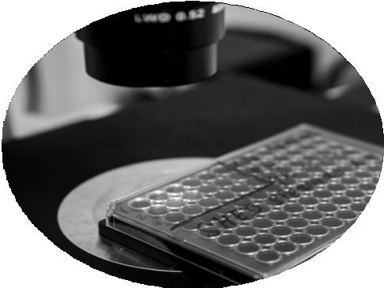ACHIEVEMENTS

An organ construct of a mouse thyroid gland has been bioprinted with rounded embryonic explants using a digital model. The bioprinted mouse thyroid gland construct
is made up of vascularized thyroid follicles and structural-functional units of the thyroid gland. Collagen with normal pH was printed using a cooling/heating system.
The bioprinted mouse thyroid gland construct has been proven functional both in vitro and in vivo based on a mouse model
of hypothyroidism

